Customer-Facing Site Screen Shots

Date Issued: 20/07/2009

Table of Contents
1 Customer-Facing Site Screenshots 4
2 Explanatory Notes 19
2.1 General – Application Level 19
2.2 Home Page 19
2.3 Department Page 19
2.4 Category Page 19
2.5 Browse Item Page 19
2.6 View Cart Page 19
2.7 View Cart Page – Currency Changed 19
2.8 View Cart Page – Country and Delivery Mode 20
2.9 Check Out Page 1 20
2.10 Check Out Page 1– Validation 20
2.11 Check Out Page 2 20
2.12 Check Out Page 4 20
2.13 Search Page 20

Table of Figures
Figure 1 - Home Page 4
Figure 2 - Department Page 5
Figure 3 - Category Page 6
Figure 4 – Browse Item Page 7
Figure 5 - View Cart Page 8
Figure 6 - View Cart Page (Changed currency) 9
Figure 7 - View Cart Page (changed shipping country and delivery mode) 10
Figure 8 - Checkout Page 1 11
Figure 9 - Check out Page 1 (Validation) 12
Figure 10 - Check out Page 2 13
Figure 11 - Check out Page 2 – Shipping Address different 14
Figure 12 - Check out Page 3 15
Figure 13 - Check out Page 4 (WIP) 16
Figure 14 - Search Page 17
Figure 15 - Contact Page 18

Customer-Facing Site Screenshots
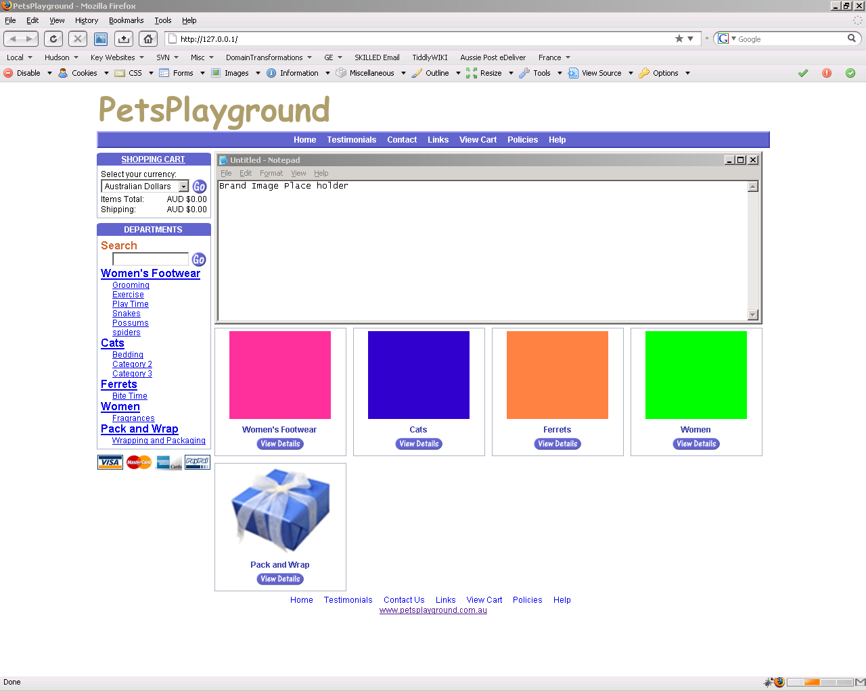
Figure 1 - Home Page

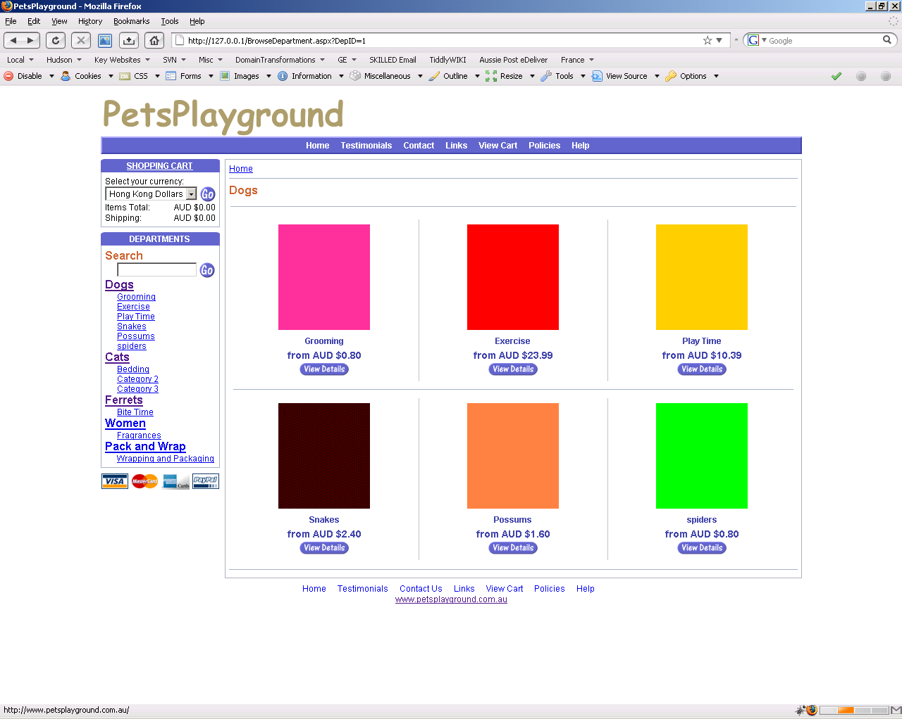
Figure 2 - Department Page
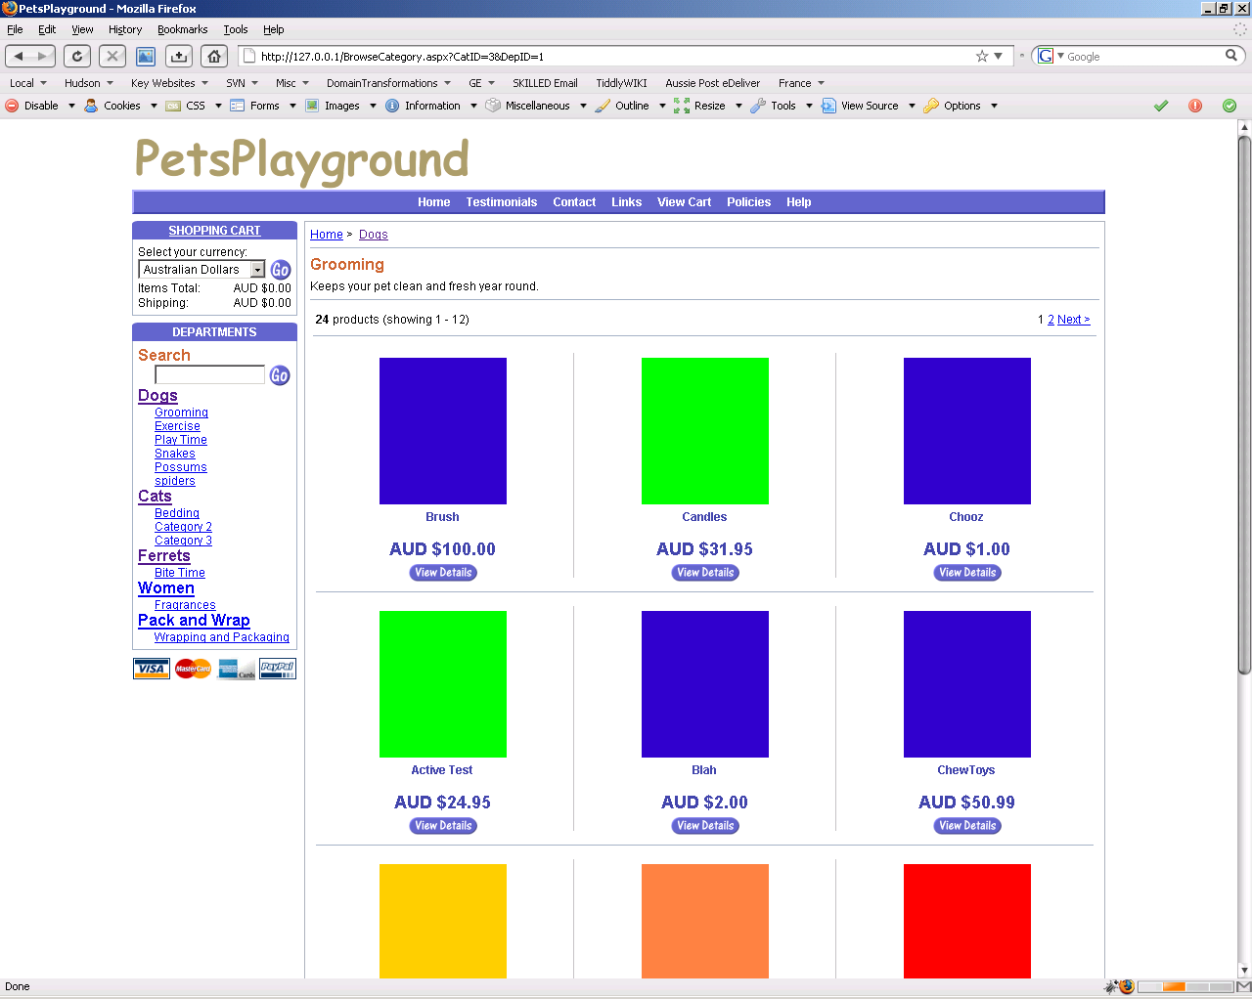
Figure 3 - Category Page
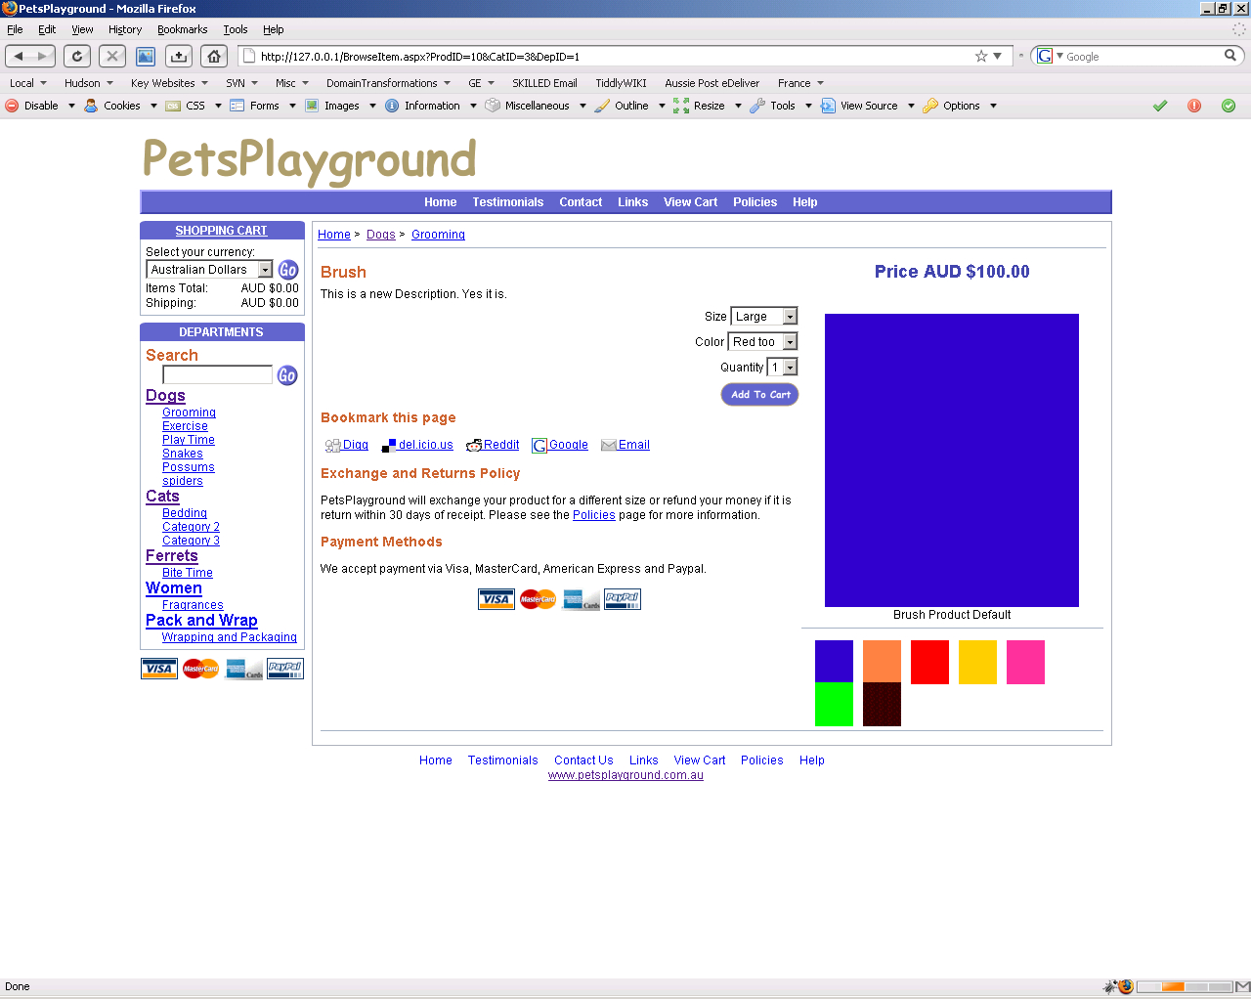
Figure 4 – Browse Item Page
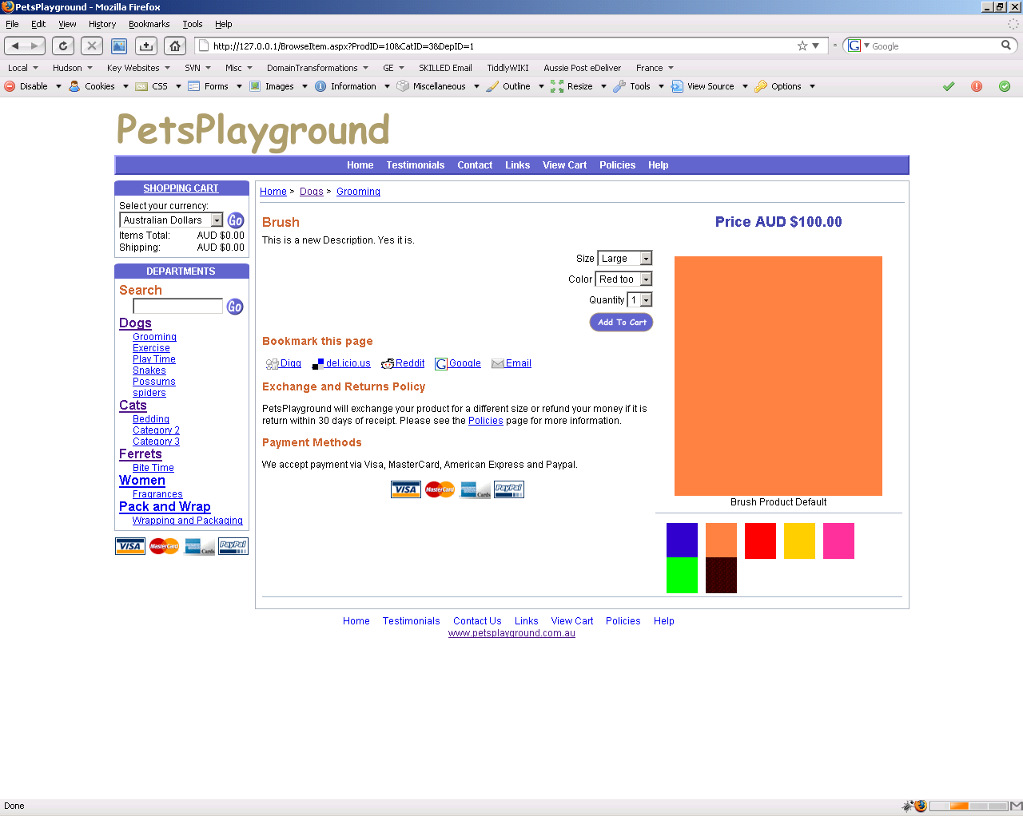
Figure 5 – Mouse Over Image Functionality
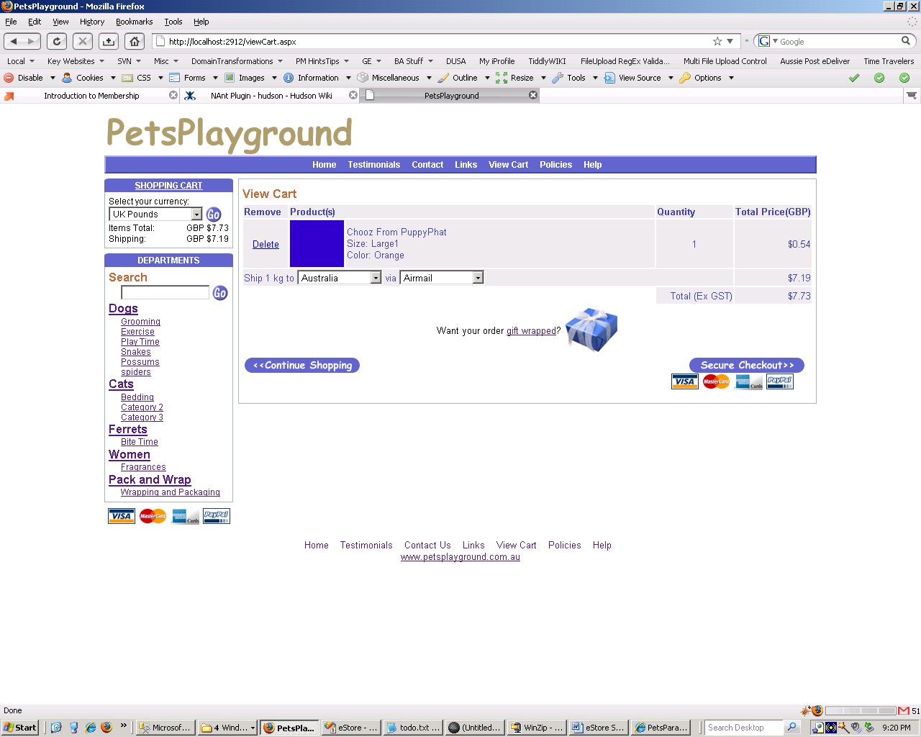
Figure 6 - View Cart Page
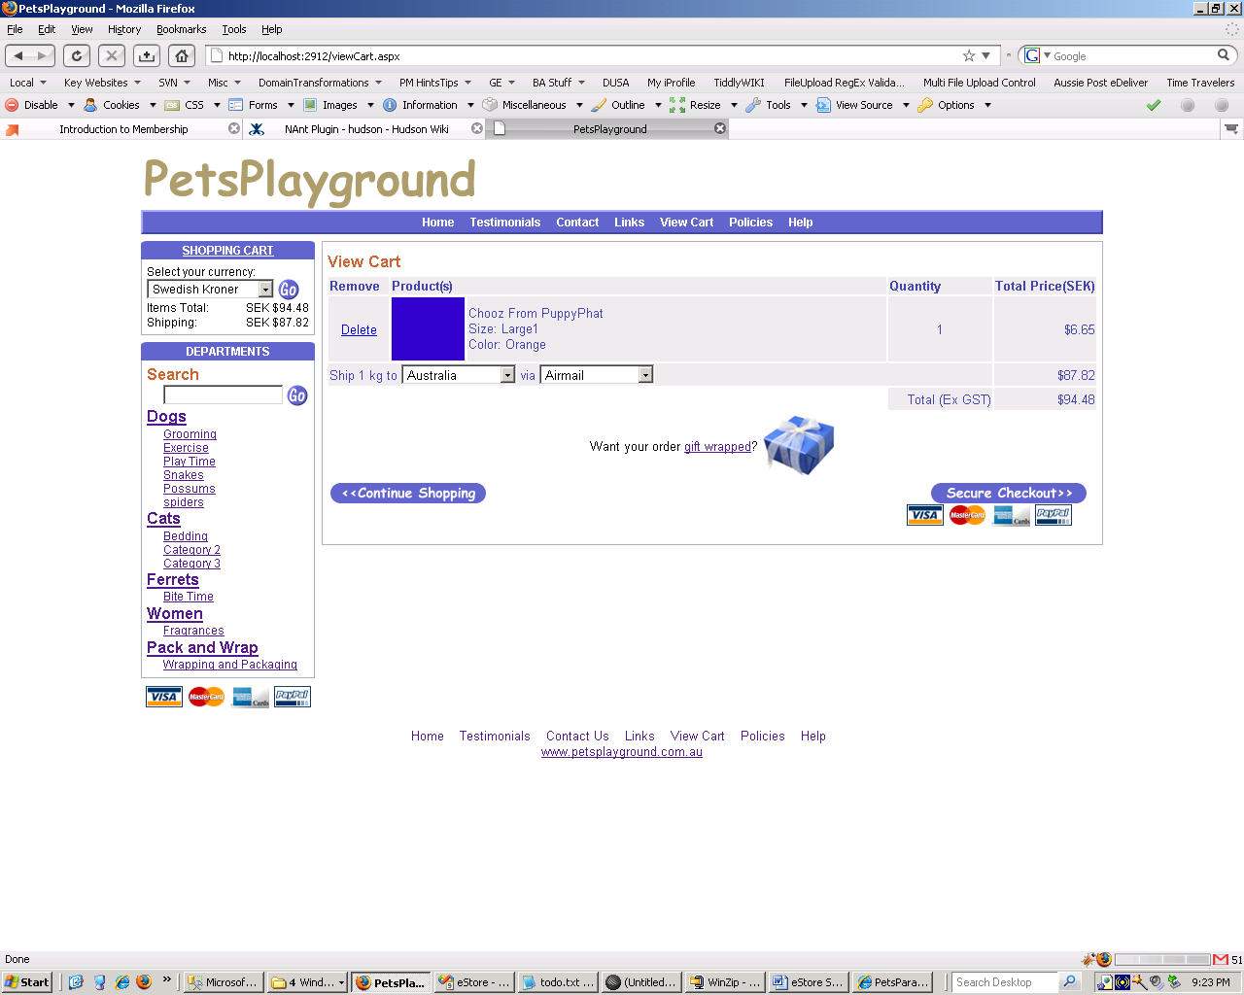
Figure 7 - View Cart Page (Changed currency)
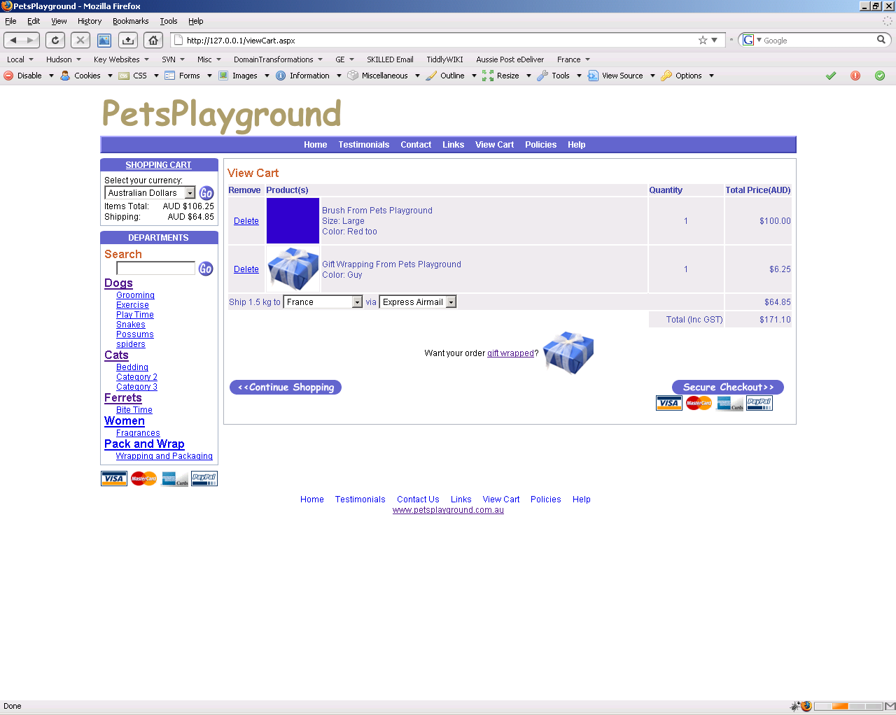
Figure 8 - View Cart Page (changed shipping country and delivery mode)
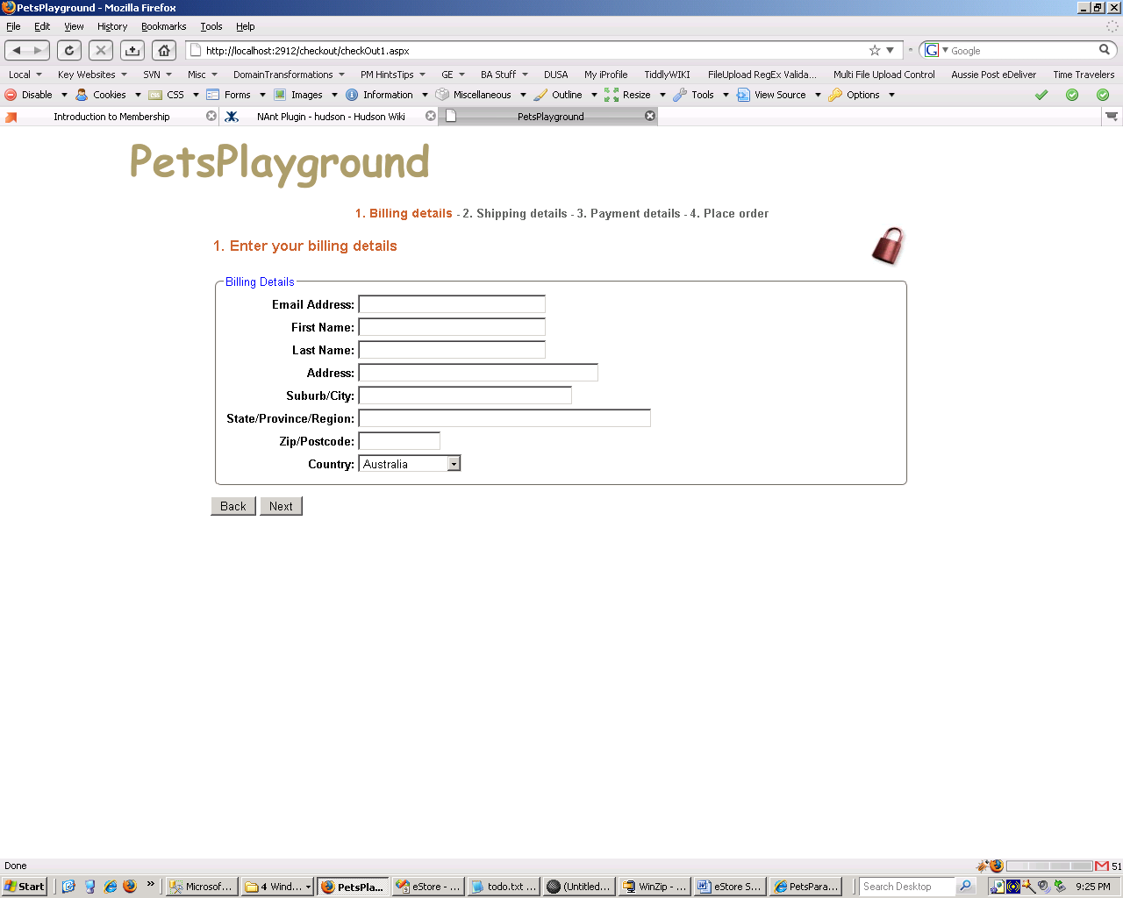
Figure 9 - Checkout Page 1
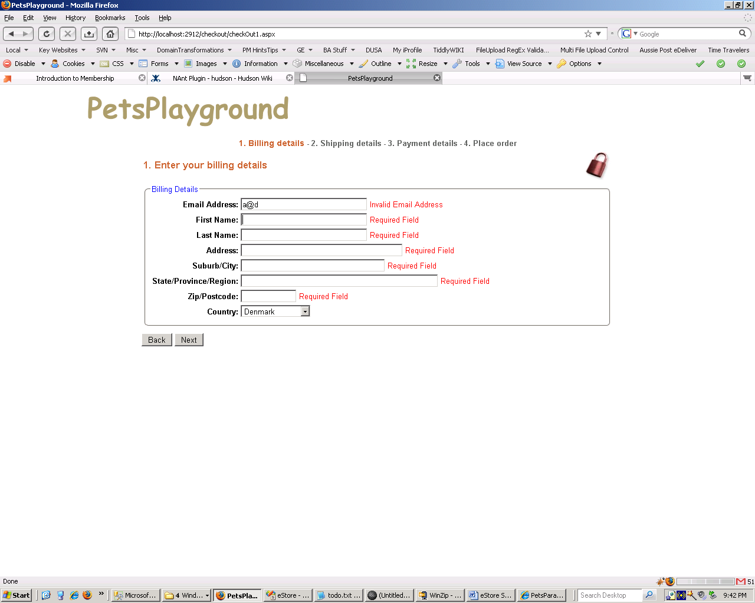
Figure 10 - Check out Page 1 (Validation)
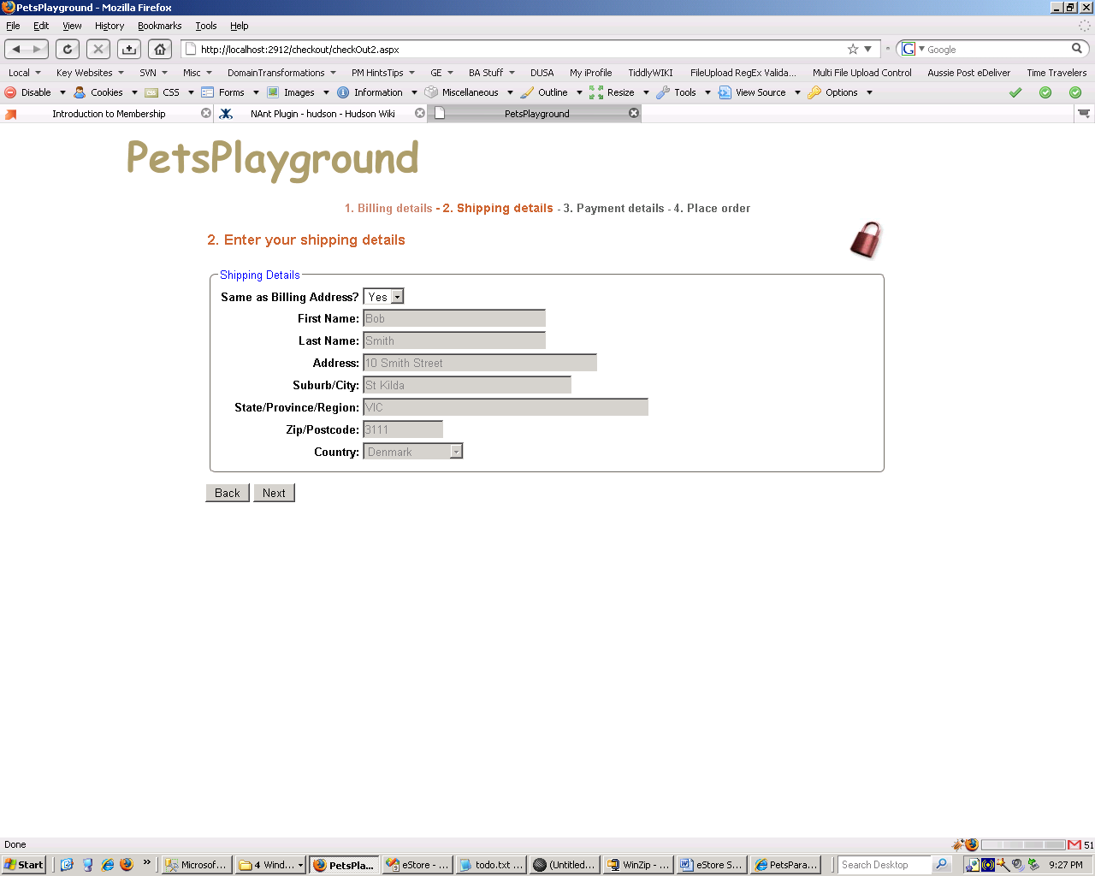
Figure 11 - Check out Page 2
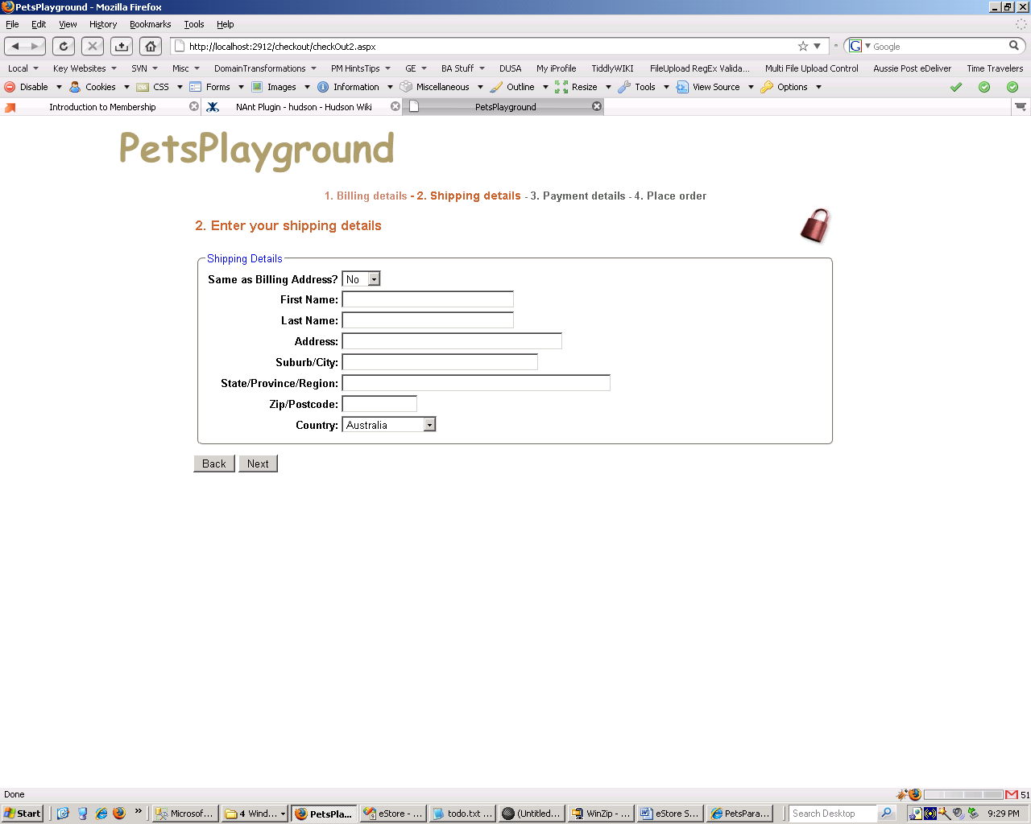
Figure 12 - Check out Page 2 – Shipping Address different
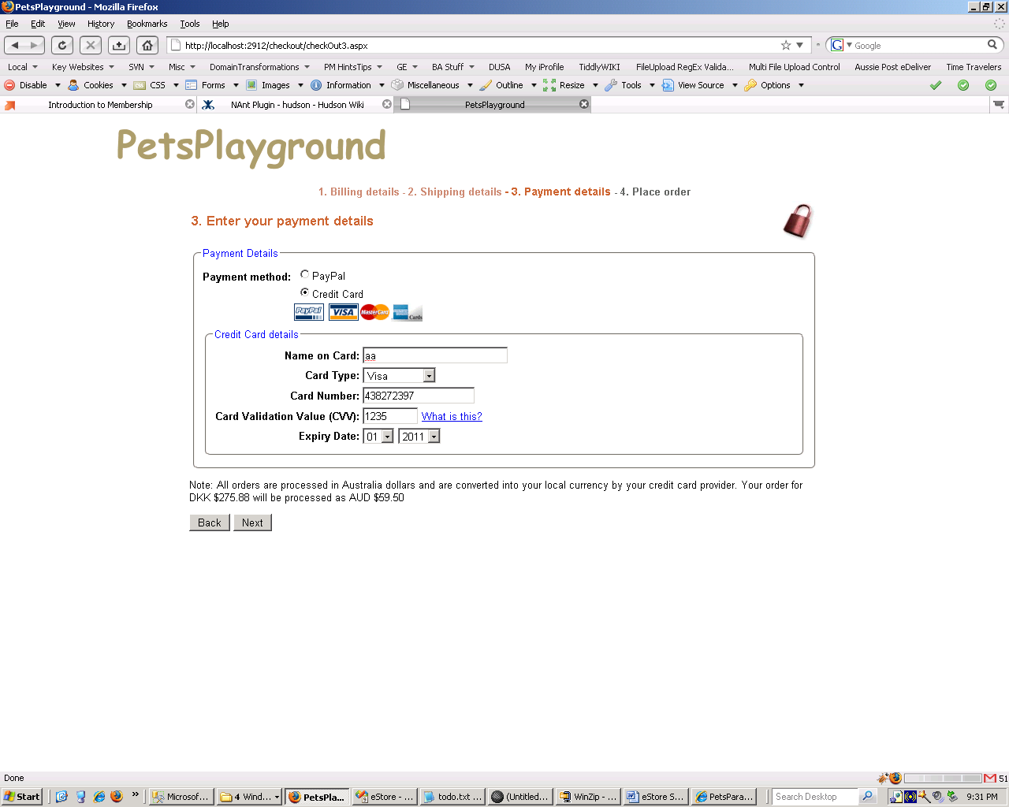
Figure 13 - Check out Page 3

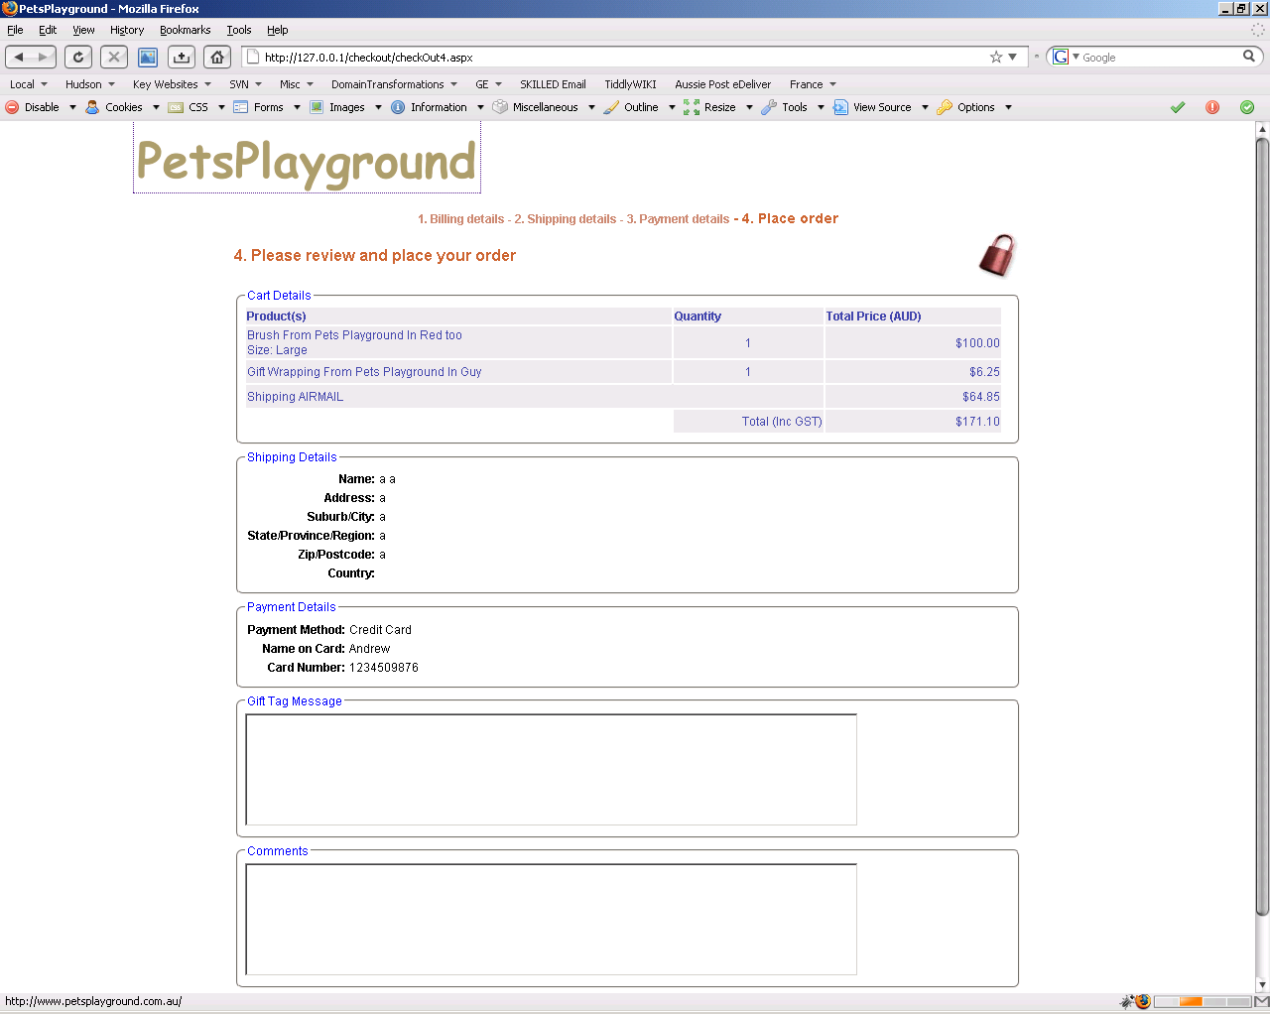
Figure 14 - Check out Page 4
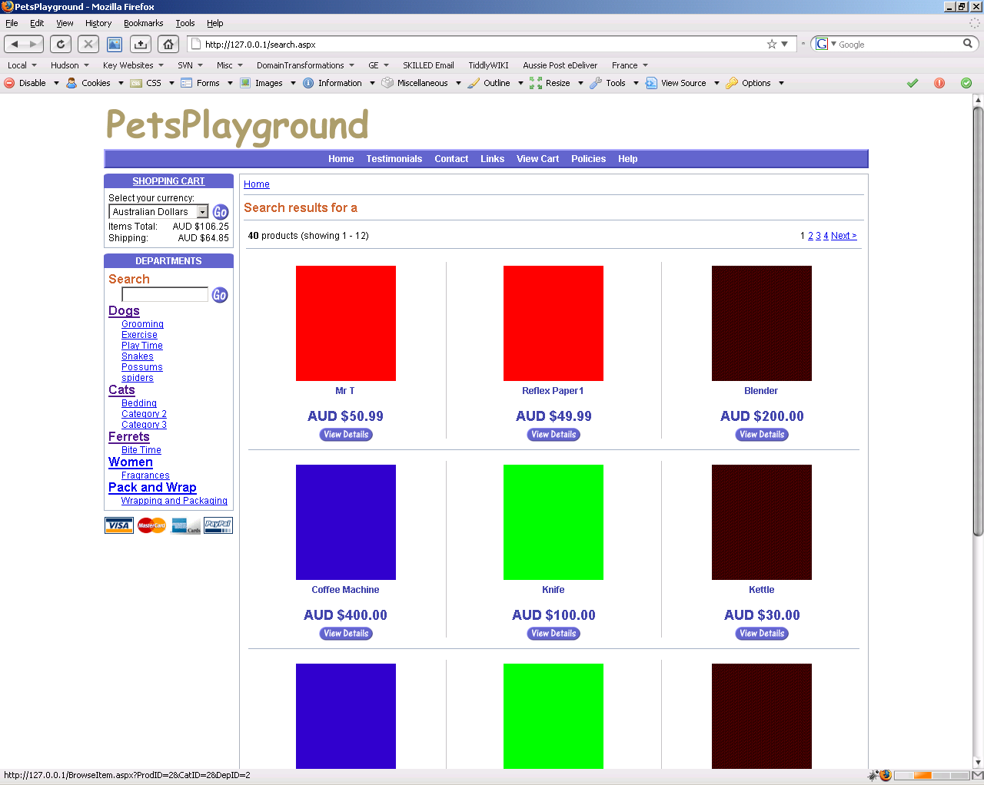
Figure 15 - Search Page
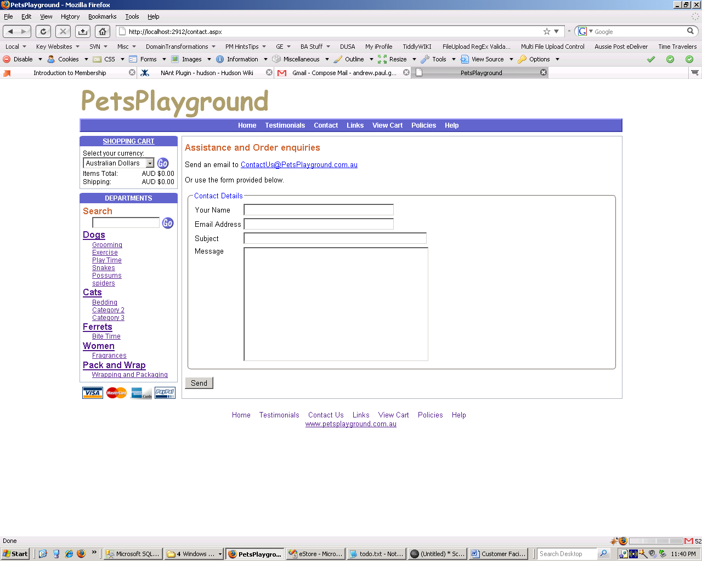
Figure 16 - Contact Page

Explanatory Notes

General – Application Level
When the application starts the current currency exchange rates are periodically refreshed via a call to a web service and stored in the database.

The images are deliberately blocks of color. I did this so that I debug the functionality in the Admin site around adding and removing images and also the setting of product and category default images. In a production these will be standardised product images.

Home Page
This page will have products marked as on special. MasterPage used across catalogue pages.

Department Page
This page utilises AJAX when the currency is changed. Pagination of departments.

Images shown are the default image for each Category (e.g. Pink for Grooming) as defined in the admin interface.

Category Page
This page utilises AJAX when the currency is changed. Pagination of Categories.

Images shown are the default image for each product (e.g. Blue for Chooz) as defined in the admin interface.

Browse Item Page
This page utilises AJAX when the currency is changed. Pagination of Products.

Size and Color dropdowns are only shown if these are defined for this product via the admin interface.

Initial main image shown is the one set as default for the image as defined in the admin interface.

Mouse over mini images (all the images for this product) will update the main image on this page.

View Cart Page
Default image for each product in cart shown.

View Cart Page – Currency Changed
Entire page reloaded and numbers refreshed accordingly.

View Cart Page – Country and Delivery Mode
Entire page reloaded and numbers refreshed accordingly on both view cart page and the SHOPPING CART box (above DEPARTMENTS) on the master page.

Check Out Page 1
Different MasterPage applied.

Check Out Page 1– Validation
Regular Expression and RequiredField validators applied on clicking Next. Validators disabled when clicking Back.

Check Out Page 2
Can use Billing Address as shipping address by default or specify No from the dropdown list and specify a different shipping address.

Check Out Page 4
Launch off page for integration with Credit Card Processor or PayPal. Order needs to be saved into the database if payment successful.

Search Page
This page utilises AJAX when the currency is changed. Pagination of Products.

Results are those of products that match search criteria.

Contact Page
Allows users to contact business. Integrates with Manage Emails page in Administration site.

